**LAB: 5**

**INTER-VLAN CONFIGURATION USING TWO SWITCHES**

**Theory:**

**Virtual Local Area Network:**

A Virtual Local Area Network (VLAN) is a networking technology that allows the creation of multiple logical networks within a single physical network infrastructure. The main purpose of VLANs is to enhance network performance, security, and manageability by logically segmenting devices into separate broadcast domains, even if they are connected to the same physical network. VLANs enable the segmentation of network traffic, providing isolation and improved network efficiency by grouping devices into separate broadcast domains. This segmentation is achieved by assigning VLAN tags to network frames, indicating their membership in a specific VLAN.

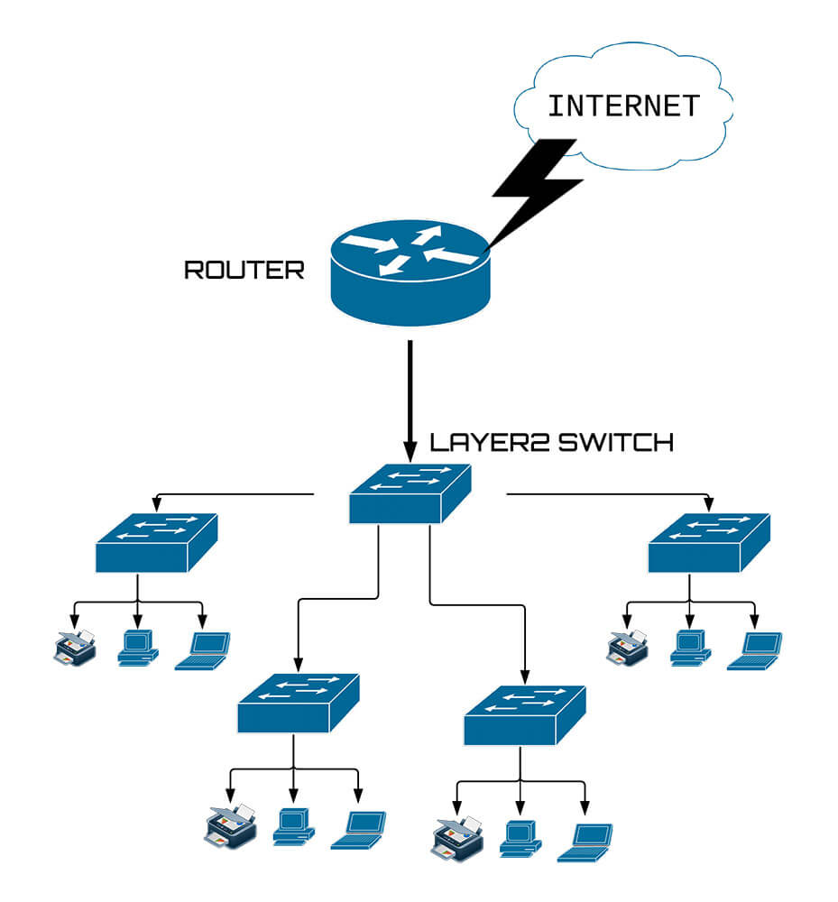

**Objective:**

To understand and creation of VLAN, IP addressing in the VLAN and establish inter-VLAN connection using two switches.

**Scenario:**

Here we are given IP address 160.2.3.0. We have to create a group of 4 pcs for accounts, sales, marketing, and finance departments under one switch. So with the help of two switches we need to set inter-VLAN connection between the same departments.

**Procedure:**

**Step 1:** Select two switches and name the switches. I have named them prasiddhi and prasiddhi1.

**Step 2:** Insert 4 pcs foraccounts, sales, marketing, and finance departments under both switches.

**Step 3:** Link every device with the switch with a straight cable and the two switches with cross-cable.

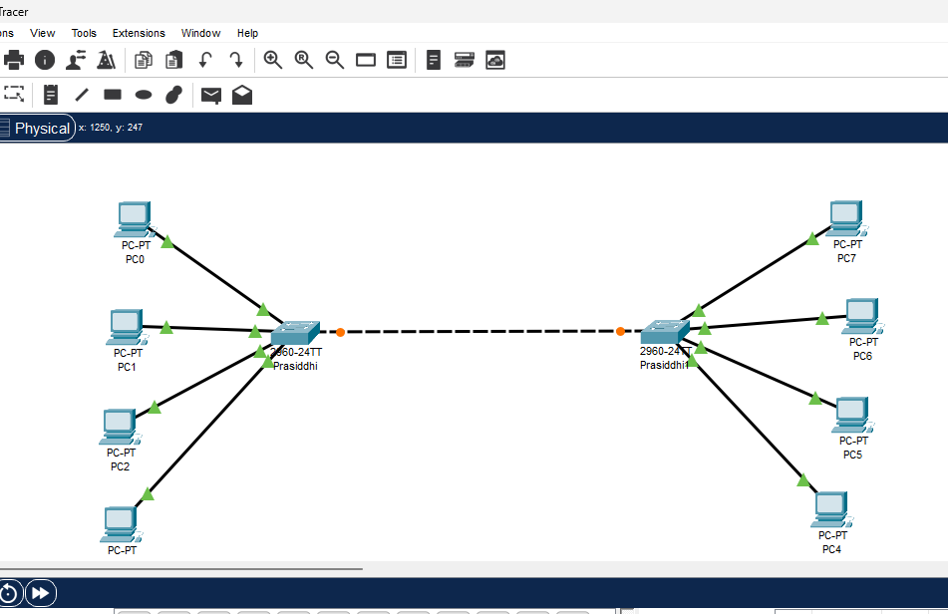

**Step 4:** Provide the IP Address to every device (given IP address is 160.2.3.0).

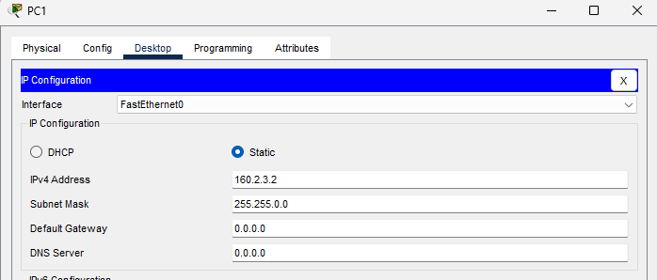

**Step 5:** Open Switch Command Line Interface for each switch and write the following Commands:

* Enable
* Configure terminal
* After this command we have to set VLAN ID and name for the VLAN.

The command are:  
 # vlan (id_number)

# name (dept_name)

# exit

Follow this command for every department.

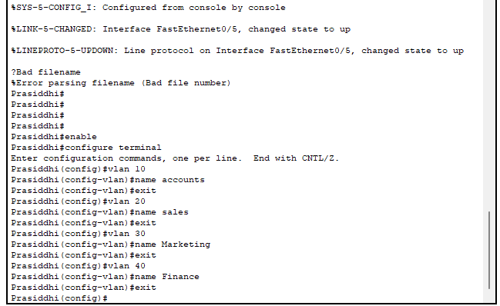

**Step 6:** Configure an interface by using these command:

interface <interface_type> <interface_number>

switchport mode access

switchport access vlan <vlan_id>

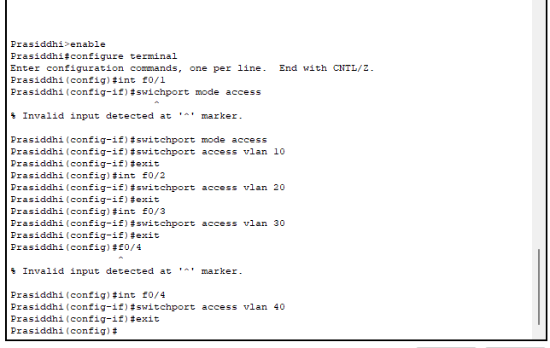

**Step 7:** To check our connection select any pc and from its command prompt try to ping the computer of same department and of different department.

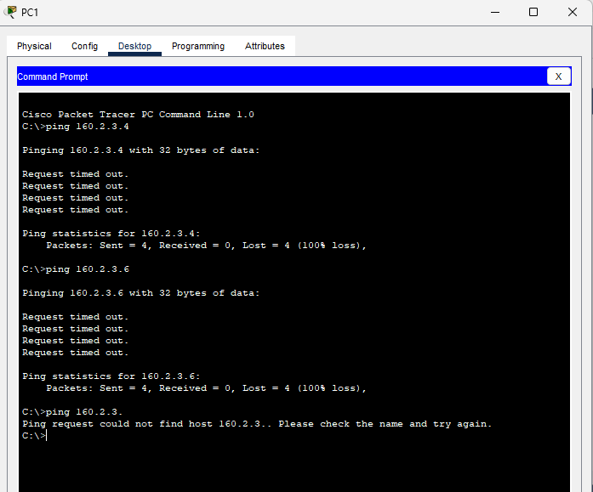

Above we can see successful ping when we try to ping the device of same department and we observe unsuccessful ping when we try to ping the device of different department.

**CONCLUSION**

Therefore in this lab, we successfully designed a Virtual Local Area Network (VLAN) for four departments named accounts, sales, marketing, and finance using two switches in Cisco Packet Tracer. The aim was to understand the creation of VLANs, IP addressing within the VLAN, and the overall process of setting up a segmented network for improved efficiency and security.